**Project Design Phase-II**

**Data Flow Diagram & User Stories**

|  |  |
| --- | --- |
| Date | 31 January 2025 |
| Team ID | LTVIP2025TMID32163 |
| Project Name | Smart SDLC – AI Enhanced Software Development Lifecycle |
| Maximum Marks | 4 Marks |

### ****Data Flow Diagram (DFD) – Smart SDLC****

A **Data Flow Diagram (DFD)** is a graphical representation that illustrates how information flows within the **Smart SDLC** system. It visually maps how data enters the application, how it is processed using AI, where it is stored, and how it is delivered back to the user.

For **Smart SDLC**, which is developed using **FastAPI** and powered by **IBM’s Granite-3.3-2b-instruct model**, the DFD helps in clearly understanding the interaction between users, system components, and data transformation across the **Software Development Life Cycle (SDLC)**.

The DFD effectively captures:

* **Inputs**: User queries, SDLC phase selection, project context
* **Processes**: FastAPI-based request handling, AI model interaction, prompt processing
* **Storage**: Temporary session data or user history (optional for personalized flow)
* **Outputs**: AI-generated phase-wise guidance and SDLC recommendations

By presenting this information flow visually, the DFD ensures stakeholders and developers can quickly grasp **how Smart SDLC operates**, from user input to intelligent output, enabling better design, debugging, and future enhancements.

Example: DFD Level 0 (Industry Standard)

**Example:** [**(Simplified)**](https://developer.ibm.com/patterns/visualize-unstructured-text/)

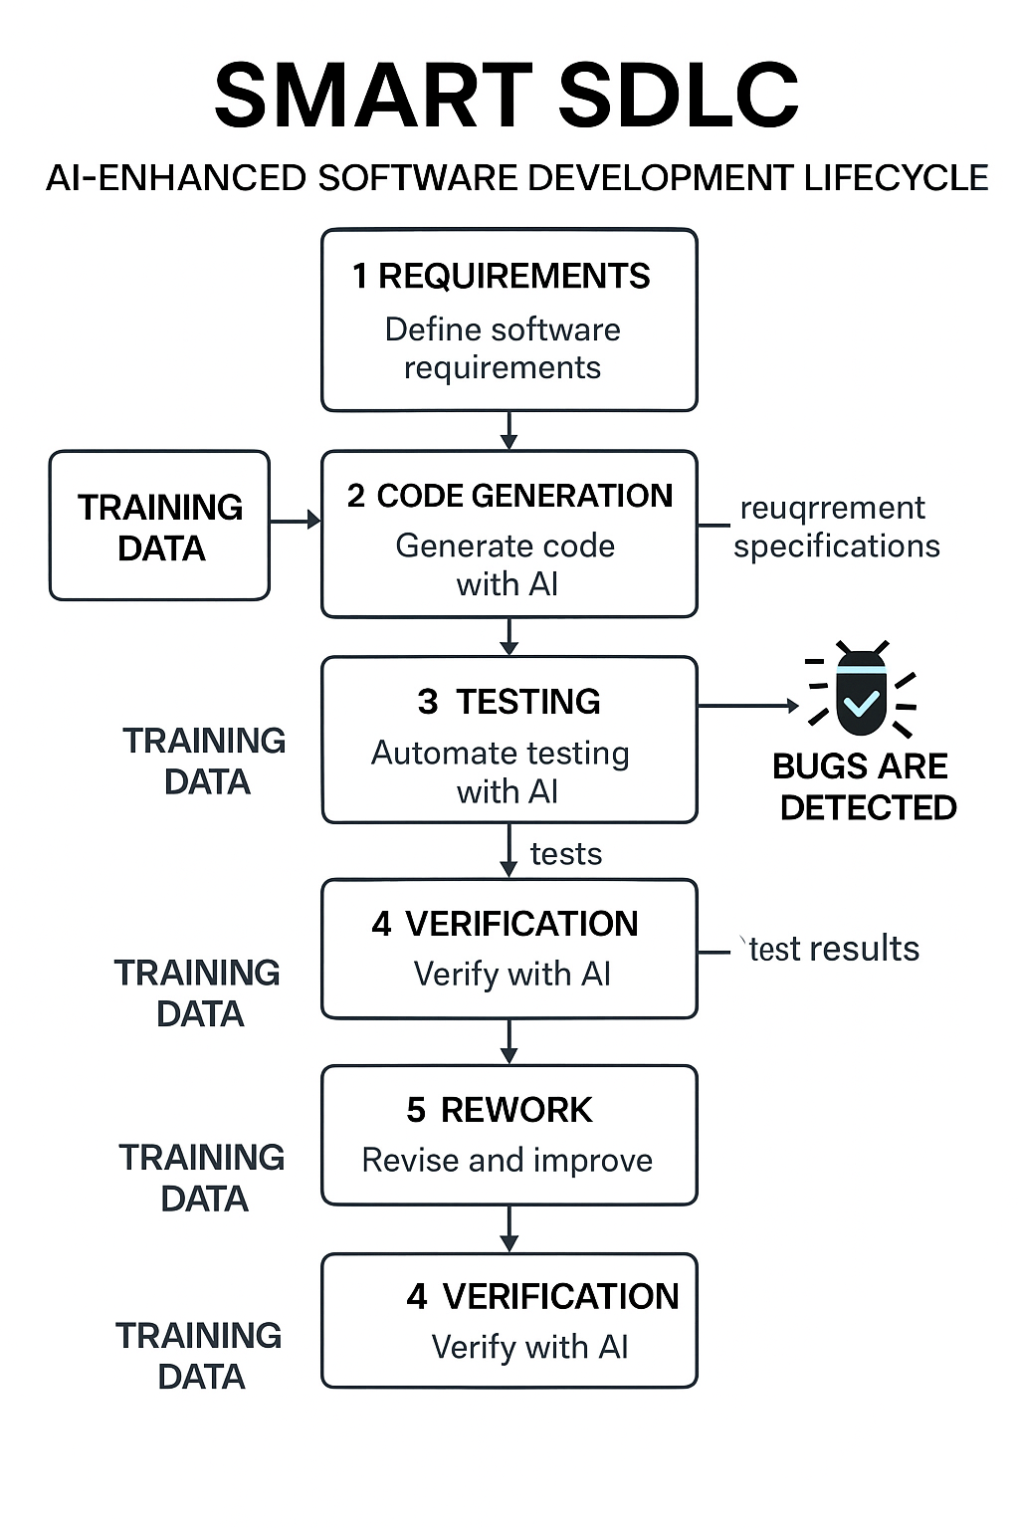

Here’s the **User Stories Table** customized for the **Smart SDLC** application, following the given format:

### ✅ ****User Stories – Smart SDLC****

| **User Type** | **Functional Requirement (Epic)** | **User Story Number** | **User Story / Task** | **Acceptance Criteria** | **Priority** | **Release** |
| --- | --- | --- | --- | --- | --- | --- |
| Developer (Web user) | Registration & Onboarding | USN-1 | As a user, I can register and create a Smart SDLC account using my email and password. | Account is created; redirected to dashboard | High | Sprint-1 |
|  |  | USN-2 | As a user, I will receive a confirmation email after successful registration. | Email is received and confirmation link is functional | High | Sprint-1 |
|  |  | USN-3 | As a user, I can register using my GitHub or Google account. | Able to sign in and access dashboard via OAuth | Medium | Sprint-2 |
| Developer (Web user) | SDLC Guidance (Phase-wise) | USN-4 | As a user, I can select an SDLC phase (e.g., Design) to get AI-generated assistance. | AI generates relevant guidance for selected SDLC phase | High | Sprint-1 |
|  |  | USN-5 | As a user, I can enter project-specific input for phase-wise suggestions. | Personalized AI suggestions are displayed | High | Sprint-1 |
|  |  | USN-6 | As a user, I can view formatted AI responses in a readable output panel. | Outputs are clean, structured, and phase-specific | Medium | Sprint-2 |
| Developer (Web user) | Dashboard | USN-7 | As a user, I can view all previous queries and AI responses organized by SDLC phases. | Past queries/responses visible per session | Medium | Sprint-2 |
| Administrator | User Management | USN-8 | As an admin, I can manage (view, delete, update) user accounts. | Admin panel functions as expected | Medium | Sprint-3 |
| Admin/Developer | Analytics & Logs | USN-9 | As an admin, I can view usage statistics for each SDLC module (phases used, traffic, etc.). | Analytics dashboard displays real-time stats | Low | Sprint-4 |
| Educator | Learning Mode | USN-10 | As a mentor, I can switch the app to a learning mode with simpler AI prompts for students. | A toggle activates student-friendly content generation | Medium | Sprint-3 |